**Differentials**

Table of Contents

Functions of Two Variables 4

Differentiability 5

For the curve $y=f\left(x\right)$, the **tangent** at the point $\left(x, y\right)$ is given by

$$\left(y-y_{1}\right)=m\left(x-x_{1}\right)$$

where $\left(x_{1}, y_{1}\right)$ is a point that is very close to the point $\left(x, y\right)$ on the same curve.

$$x_{1}=x+∆x$$

$$y_{1}=x+∆y$$

$∆x$**and $∆y$**  are also denoted as $dx$ **and $dy$**  and $m$ is also denoted as $f^{'}\left(x_{1}\right)$. However, there is a small issue here. Consider the graph below:

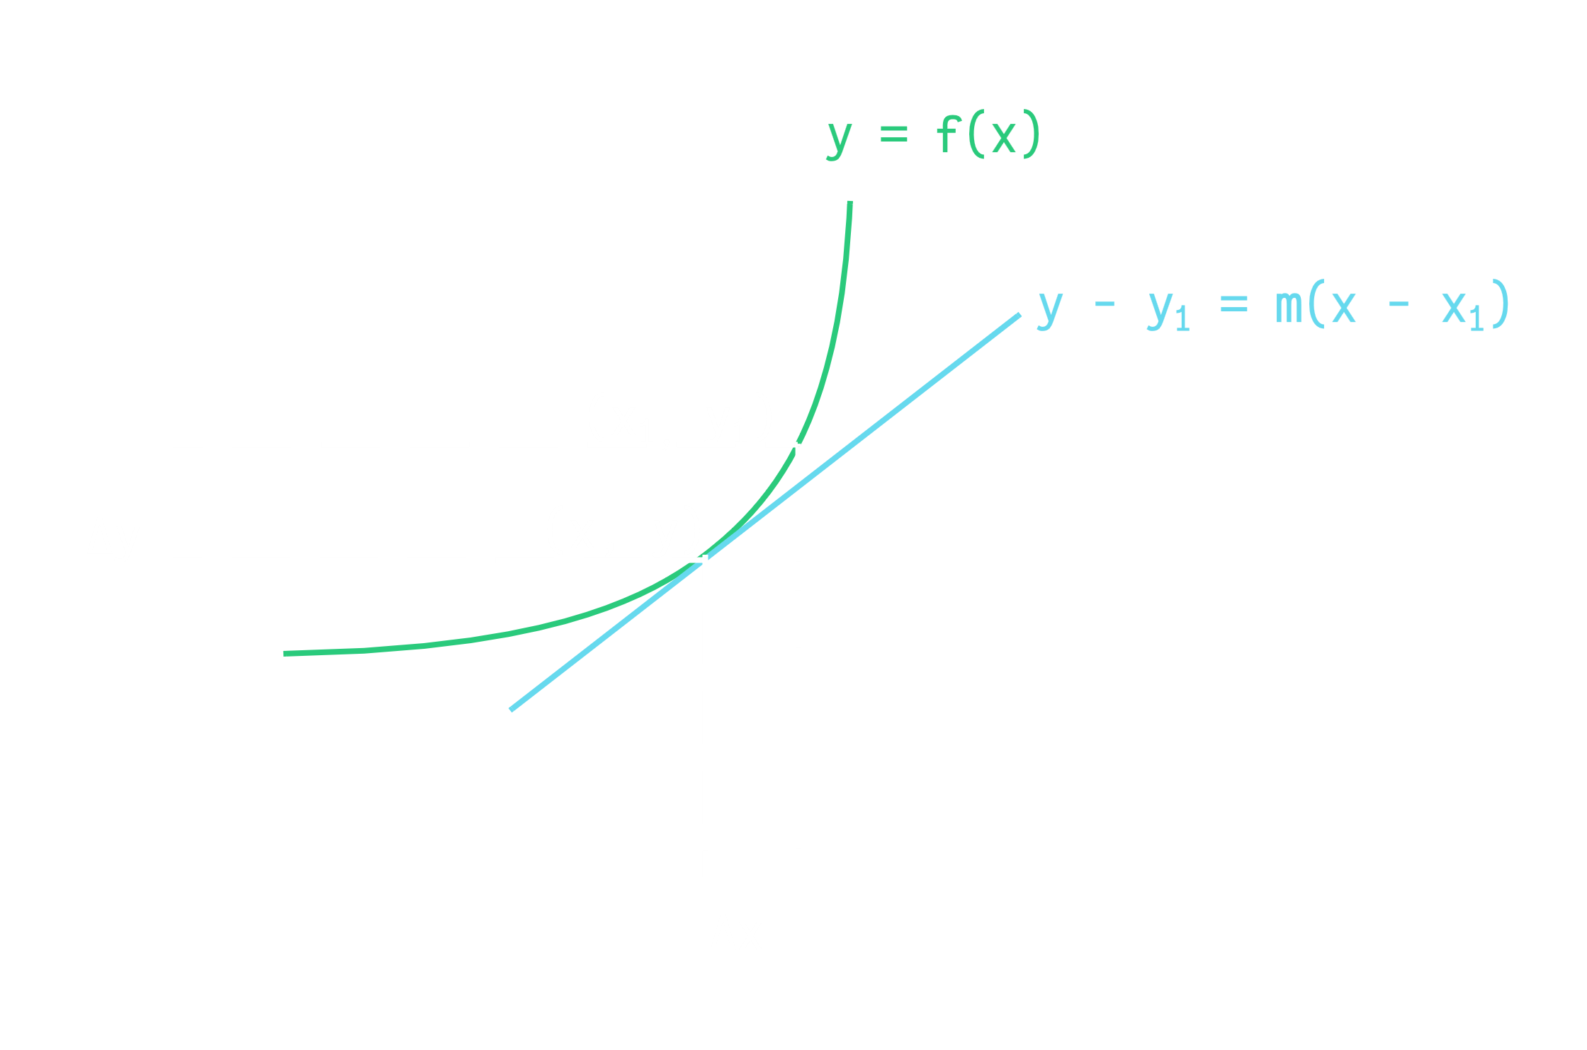

At the point $\left(x_{1}, y_{1}\right)$, there is a **tiny difference** between the **curve** and the **tangent**. If we consider the **vertical** difference, the height different between $\left(x, y\right)$ and $\left(x_{1}, y_{1}\right)$ on the **tangent** is $dy$, while the height difference between the same points on the **curve** is $∆y$. $∆y$ is the **increment** and $dy$ is the **differential**. We assume that $∆y≈dy$.

From here,

$$y-y_{1}=f^{'}\left(x_{1}\right)\left(x-x_{1}\right)$$

$$y=y_{1}+f^{'}\left(x_{1}\right)\left(x-x_{1}\right)$$

$$L\left(x\right)=f\left(x_{1}\right)+f^{'}\left(x_{1}\right)\left(x-x_{1}\right)$$

We switched from $y$ to $L\left(x\right)$, to indicate that this is the **linear approximation** of $y$, not the exact value of $y$ at $f\left(x\right)$.

Say $y=f\left(x\right)=\sqrt{37}$. The square root of $37$ is a little difficult to find, so lets say we decide $x_{1}=36$. Thus,

$$L\left(x\right)=f\left(x_{1}\right)+f^{'}\left(x_{1}\right)\left(x-x_{1}\right)$$

$$=\sqrt{36}+\frac{1}{2\sqrt{36}}\left(37-36\right)$$

$$=\frac{73}{12}$$

This gives us $6.083$. The exact value of $\sqrt{37}$ is $6.08276…$.

## Functions of Two Variables

If we start considering functions of **two variables**, we get similar terminology. For $z=f\left(x, y\right)$, $∆x$ and $∆y$ are the increments of $x$ and $y$ respectively and the increment of $z$ is given by:

$$∆z=f\left(x+∆x, y+∆y\right)-f\left(x, y\right)$$

Since we are using **linear approximation**, we can say that $dx=∆x$ and $dy=∆y$. Based on this,

$$dz=\frac{δz}{δx}dx+\frac{δz}{δy}dy=f_{x}\left(x, y\right)dx+f_{y}\left(x, y\right)dy$$

We can of course extend this to accommodate more independent variables.

## Differentiability

For a **differentiable** function, $y=f\left(x\right)$, we can say that the differential $dy=f^{'}\left(x\right)dx$ is **approximately** the same as $∆y=f\left(x+∆x\right)-f\left(x\right)$.

A similar approximation can be made for functions of **two variables**, and if the approximation can be made, the function is said to be differentiable at the point $\left(x_{0}, y_{0}\right)$.

$$∆z=f_{x}\left(x_{0}, y_{0}\right)∆x+f_{y}\left(x_{0}, y_{0}\right)∆y+ε_{1}∆x+ε_{2}∆y$$

Here, both $ε_{1}$ and $ε_{2}→0$ as $\left(∆x, ∆y\right)→\left(0, 0\right)$.

The function is further said to be **differentiable in a region $R$** if it is differentiable at **every point** in the region.

Say we have a function $f\left(x, y\right)=x^{2}+3y$.

$$∆z=f\left(x+∆x, y+∆y\right)-f\left(x, y\right)$$

$$={\left(x+∆x\right)}^{2}+3\left(y+∆y\right)-x^{2}-3y$$

$$=2x∆x+{\left(∆x\right)}^{2}+3∆y$$

$$=2x∆x+3∆y+∆x∆x+0∆y$$

$$=f_{x}\left(x, y\right)∆x+f_{y}\left(x, y\right)∆y+ε_{1}∆x+ε_{2}∆y$$

Thus, $f$ is differentiable.

If $f$ is a function of $x$ and $y$ and $f_{x}$ and $f_{y}$ are **continuous** in an open region $R$, this is a **sufficient condition** to say that $f$ is **differentiable** in $R$. Similarly, if $f$ is **differentiable** at a point $\left(x_{0}, y_{0}\right)$, it is also **continuous** at that point. However, note that $f$ itself being continuous does not guarantee that it is differentiable. Both $f_{x}$ and $f_{y}$ must be continuous for $f$ to be differentiable.

For very small values of $∆x$ and $∆y$, we can ignore $ε_{1}$ and $ε_{2}$. This makes $∆z≈dz$. Thus,

$$dz=\frac{δz}{δx}∆x+\frac{δz}{δx}∆y$$

The approximation of $∆z=dz$ is again, a **linear approximation**.